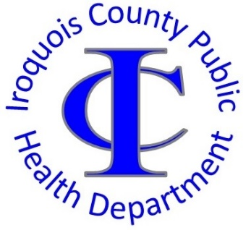
Dee Ann Schippert, Public Health Administrator
PRESS RELEASE
Date: October 21, 2022

FOR RELEASE THE WEEK OF:
Immediate Release

Contact: Tyler Robinson
815-432-2483
trobinson@co.iroquois.il.us

Breast Cancer Awareness Month
October is Breast Cancer Awareness Month. The Iroquois County Public Health Department (ICPHD) encourages individuals to have appropriate cancer screenings regularly. Self-screening for breast cancer includes breast self-exams to monitor for lumps, discharge, or other changes in skin or breast tissue. Individuals should work with a healthcare provider to have screenings including clinical exams and mammography.
ICPHD partners with the Illinois Breast and Cervical Cancer Program (IBCCP) to promote breast and cervical cancer screenings and treatments. IBCCP provides free breast and cervical screenings for uninsured individuals between the ages of 21-64. Individuals may also qualify for assistance if:
- They are over the ages of 64 and do not qualify for Medicare, have no insurance, are underinsured, or have a high deductible
- They have health insurance that doesn’t cover screenings or has a high deductible
- Younger individuals with symptoms or that are considered high risk
- Individuals already diagnosed with breast or cervical cancer may also receive free or low-cost treatment through this program

To learn more about the Illinois Breast and Cervical Cancer Program, call the Iroquois County Public Health Department at (815) 432-2483.

